**RS2304 (HG38) AutoMap**

***MICU1***

**RS2304 Homozygosity Mapper**

***MICU1***

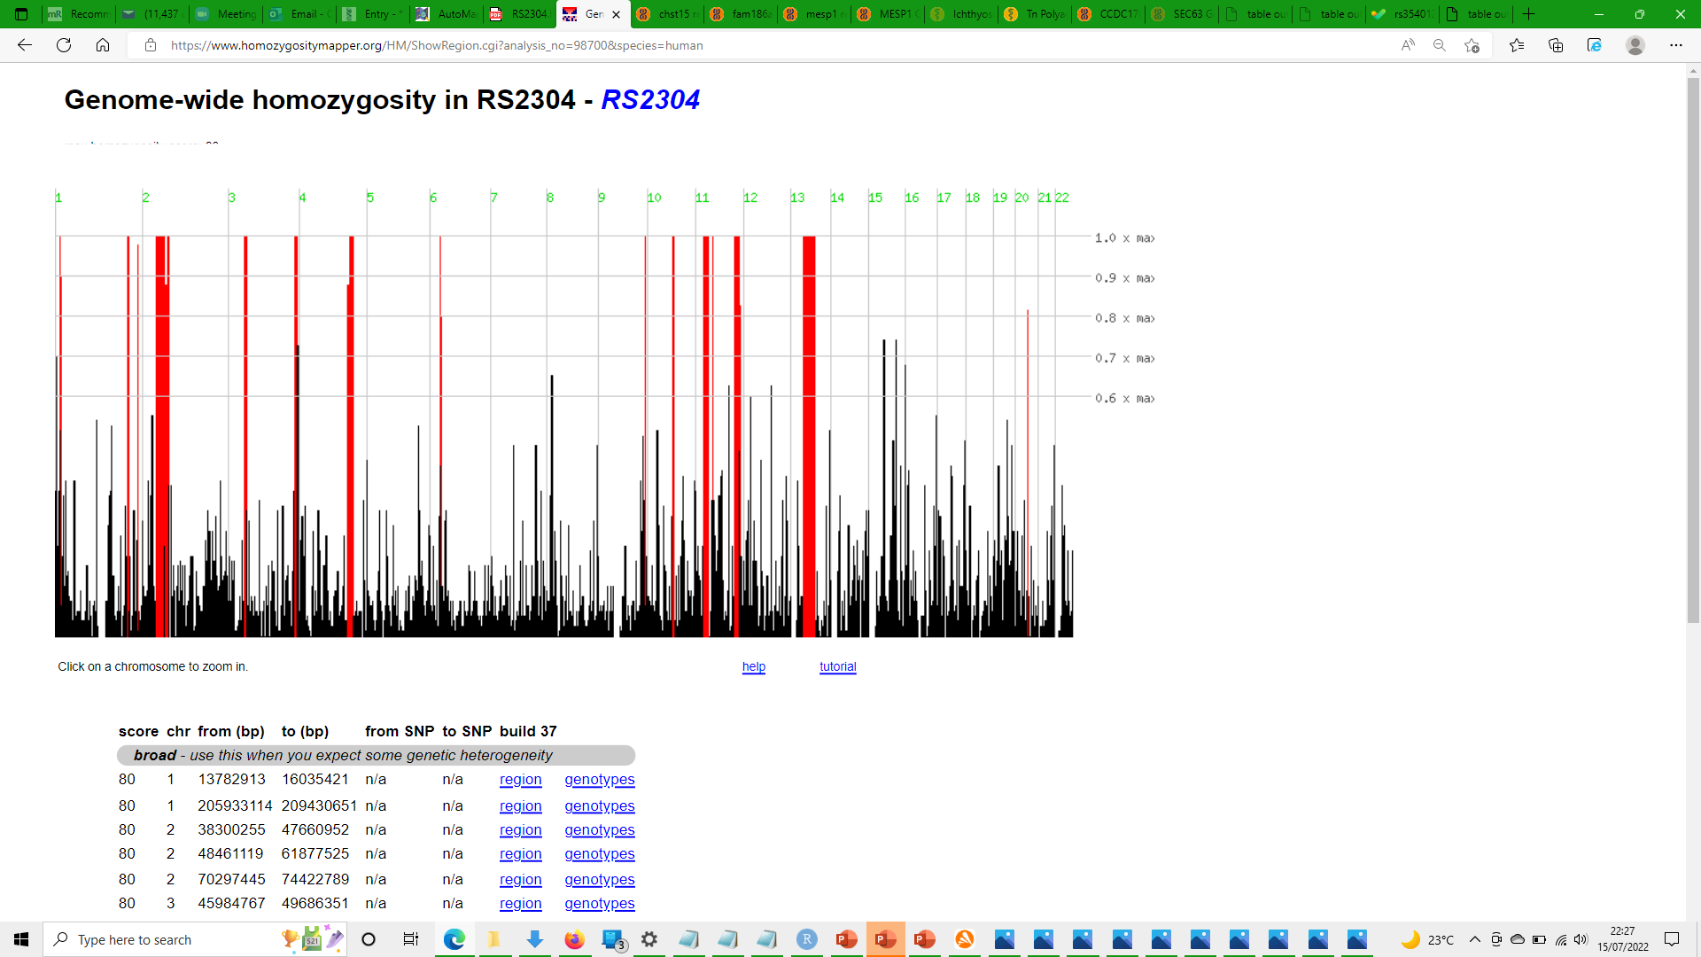

**RS2262 (HG38) AutoMap**

***SH3TC2***

**RS2262 Homozygosity Mapper**

***SH3TC2***

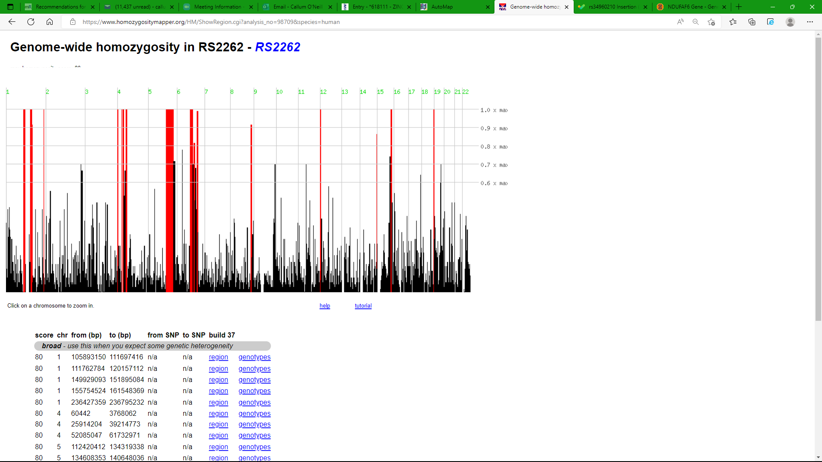

**RS2297 (HG38) AutoMap**

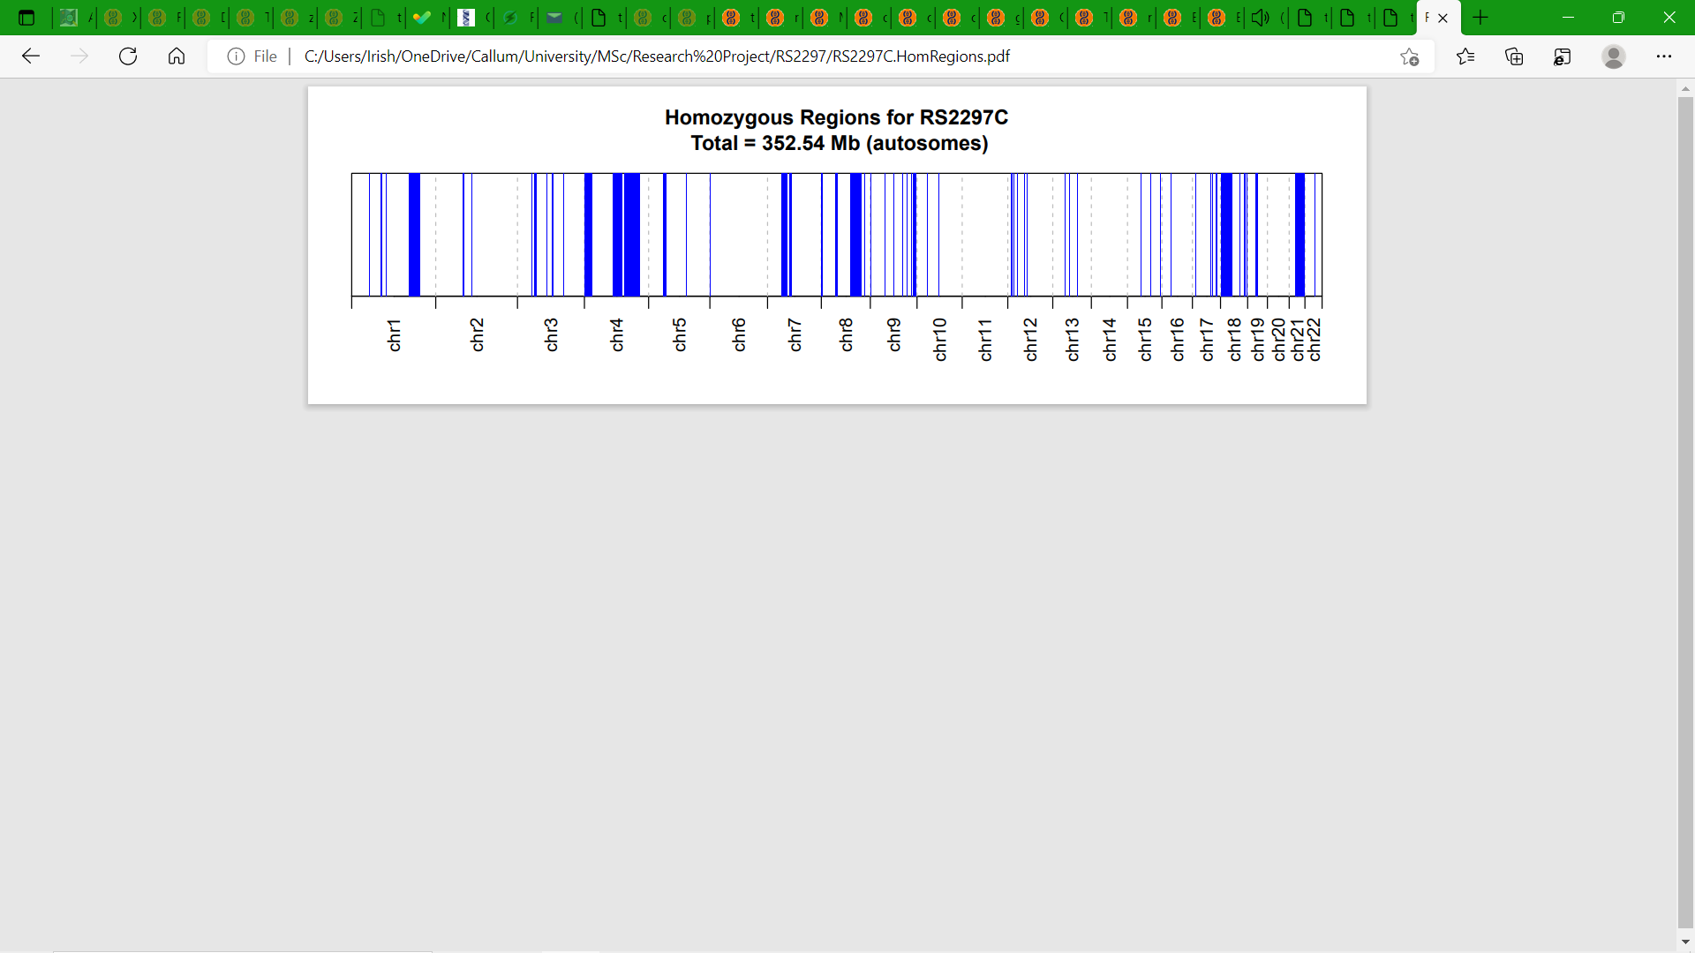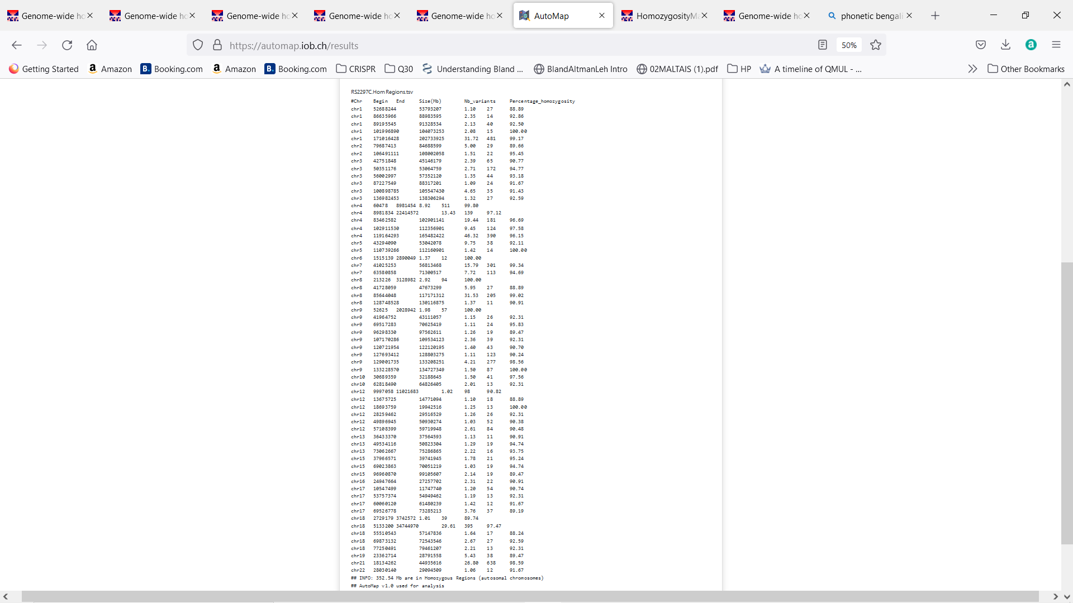

**RS2297 Homozygosity Mapper**

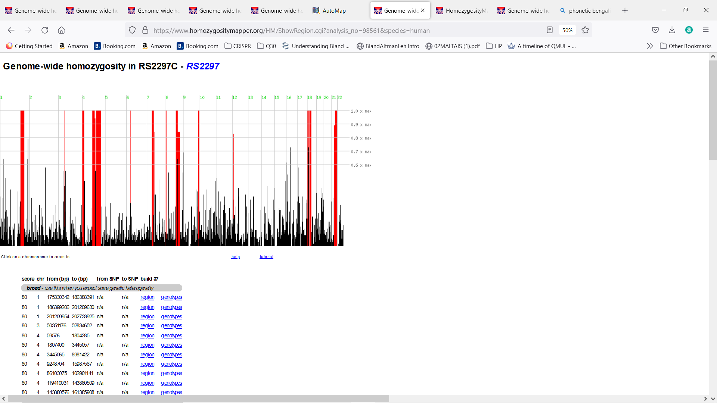

**RS12 (HG19) AutoMap**

***GPR89B***

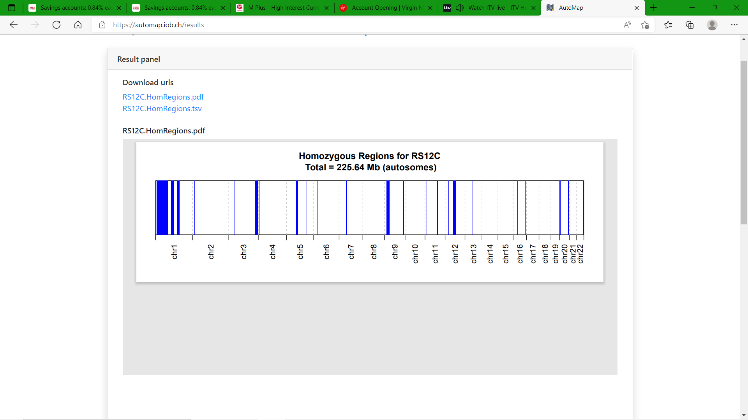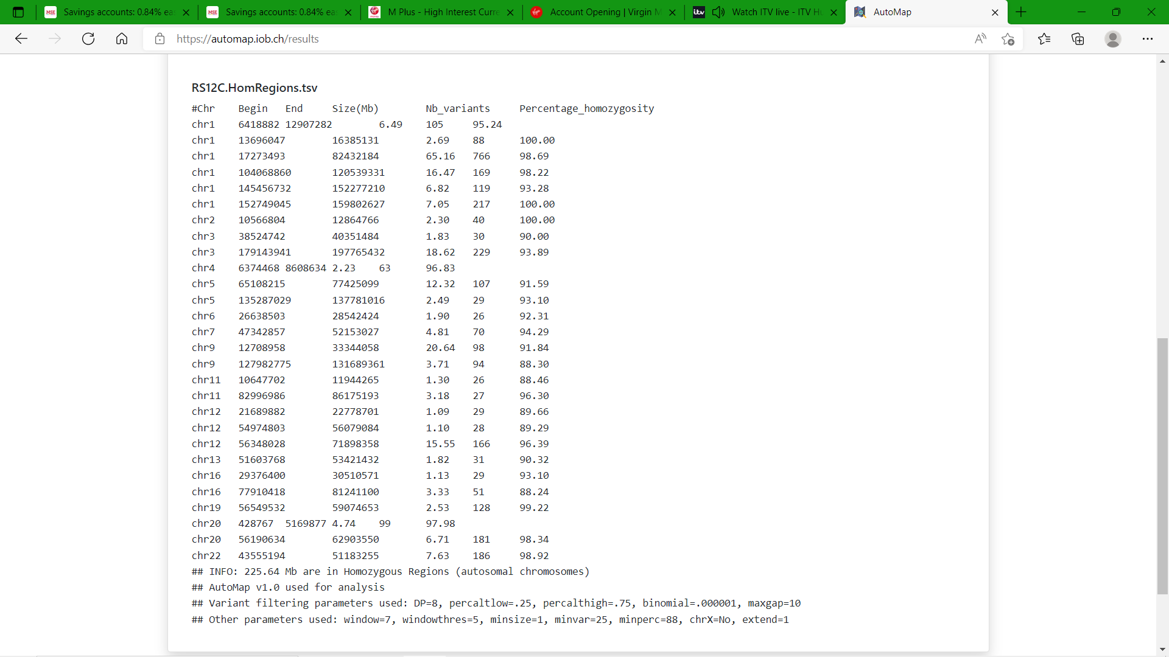

**RS12 Homozygosity Mapper**

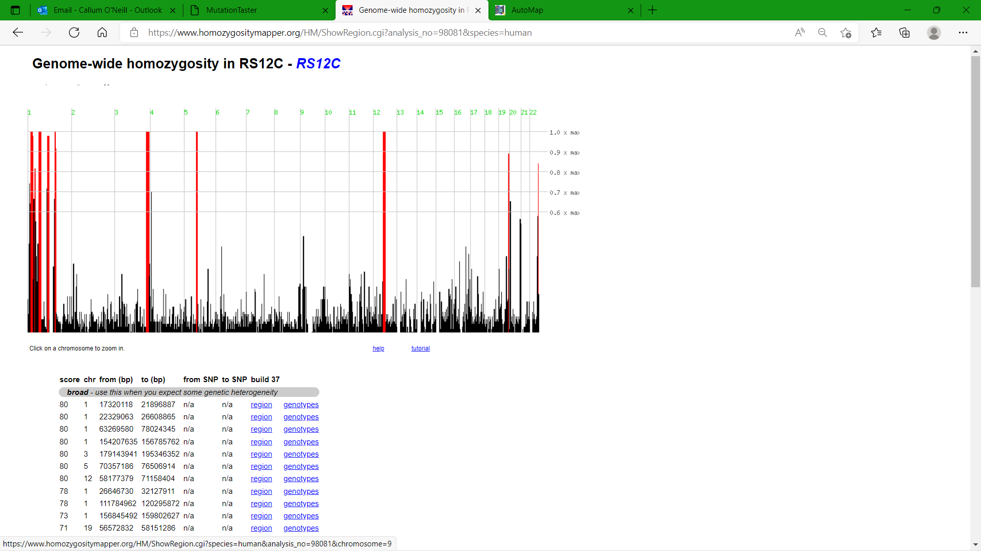

***GPR89B***

**RS290 (HG38) AutoMap**

**RS290 (HG19) AutoMap**

***ATP6V1F***

**RS290 Homozygosity Mapper**

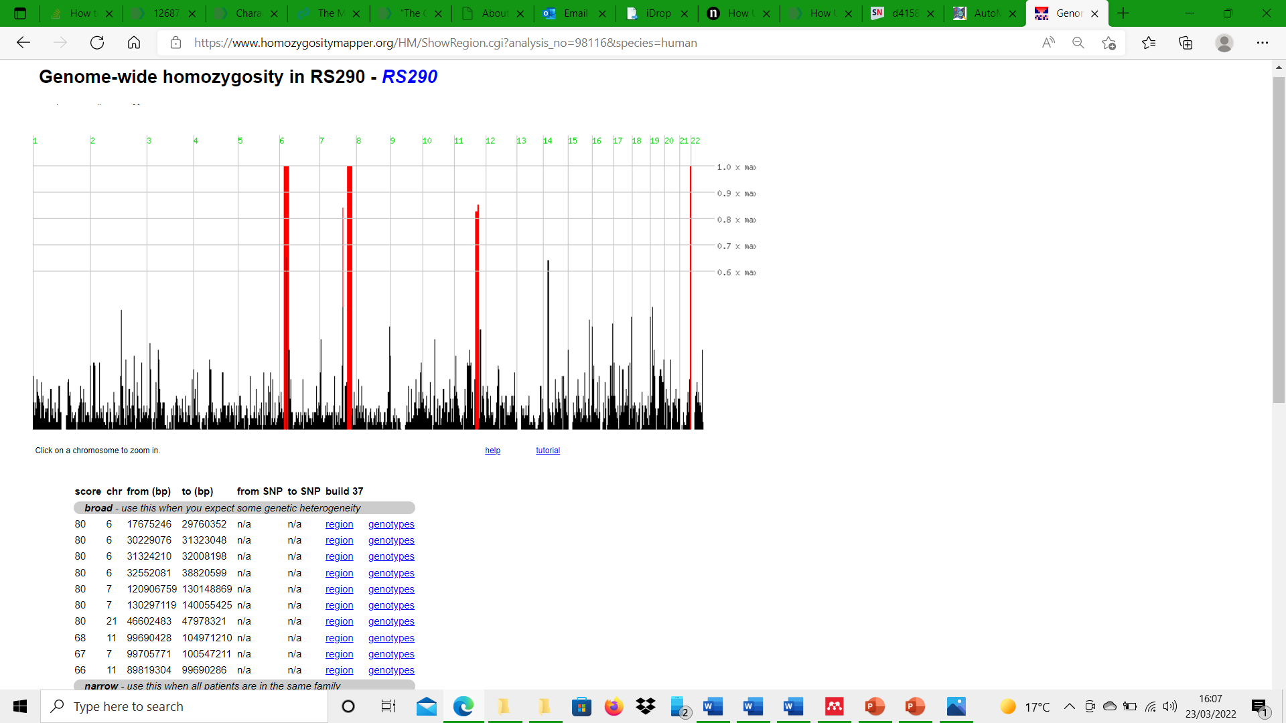

***ATP6V1F***

**T3-SHD-07 (HG38) AutoMap**

***FAM98B***

**T3-SHD-07 Homozygosity Mapper**

***FAM98B***

